Name: | ___________________________________________________ |  | Date: ___________
 | Year 9 Maths  Investigation 2, 2012  Topic – Space and Measurement  In class component ONLY |  | 42  = %
Total Time: | 45 minutes | BONUS MARKS (look at the whole assessment):   Units: appropriate (+1). If inconsistent (+1/2 only)
Reading Time: | 5 minutes
Working Time: | 40 minutes
Weighting: | 4% of the year.
Equipment: | Calculator
Important Information:
This investigation will be completed under test conditions. Answers should be rounded appropriately. All working should be shown in the space provided. Your working should be in sufficient detail to allow your answers to be checked readily and for marks to be awarded for reasoning. Incorrect answers given without supporting reasoning cannot be allocated any marks. For any question or part question worth more than two marks, valid working or justification is required to receive full marks.

No pen, pencils, highlights etc. may be used during reading time. This time is to be used to read through the assessment and check that you understand what is being asked of you. You may speak with the teacher/supervisor during this time (by putting up your hand and waiting patiently for them to approach you) but you may only ask clarification questions and not how to solve the problems. After reading time has ended, you may not ask any more questions.

AIM: In this assessment, you will be investigating the perimeter of figures made from 1cm squares..

Marks Summary
Task | Marks available | Marks awarded
1 | 2
2 | 14
3 | 3
4 | 5
5 | 5
6 | 12
Bonus | 1
Part 2 | 42

Task 1:  [2 Marks] | These diagrams show two arrangements of nine squares, which touch either along a side or on a corner.  If each square has sides of 1cm,  Shape A has 9 shared sides and the distance around (perimeter of) shape A is 18 cm. | A)  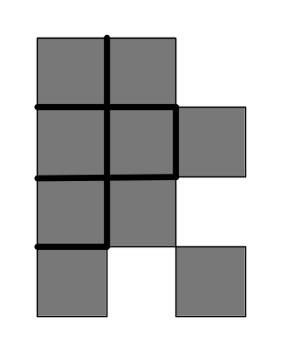
 | Shape B has five shared sides. Show how the distance around the shape is calculated to be 26 cm. | B)  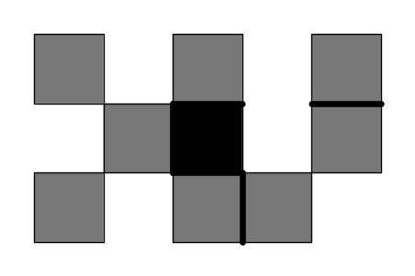  [2]

Task 2: [14 Marks]
Draw 7 other arrangements of nine squares that are different to the ones above and different to each other.
(Note: The squares must be connected in different ways. Rotated or flipped versions of a shape are not permitted.
These will be labelled 1 to 7.)
When you have drawn the shapes, calculate the perimeter and record the perimeter and number of shared sides in the appropriate place in the table in Task 3.
 | Shape 1: One shared side  Perimeter: __________ [1] | Drawing:  [1]
 | Shape 2: Two shared sides  Perimeter: __________ [1] | Drawing:  [1]
 | Shape 3: Three shared sides  Perimeter: __________ [1] | Drawing:  [1]
 | Shape 4: Four shared sides  Perimeter: __________ [1] | Drawing:  [1]
 | Shape 5: Five shared sides  Perimeter: __________ [1] | Drawing:  [1]
 | Shape 6: Six shared sides  Perimeter: __________ [1] | Drawing:  [1]
 | Shape 7: Seven shared sides  Perimeter: __________ [1] | Drawing:  [1]

Task 3 | Summary table for nine squares [ 3 Marks: 1, 2]
a) | [1]
  Shape | Number of shared sides | Perimeter (cm)
  A | 9 | 18
  B | 5 | 26
  1
  2
  3
  4
  5
  6
  7
b) | In what way does the number of shared sides affect the size of the perimeter  [2]

Task 4: [5 Marks: 2, 1, 2]
 | The minimum perimeter around any of these nine square arrangements is 12 cm
a) | Draw the shape that gives this minimum perimeter. | [2]
b) | Describe what type of shape gives this minimum perimeter. | [1]
c) | Explain why you think this shape might give the minimum perimeter. |   [2]

Task 5: [5 Marks: 2, 1, 2]
 | The maximum perimeter around any of these nine square arrangements is 36 cm
a) | Draw the shape that gives this maximum perimeter. | [2]
b) | Describe what type of shape gives this maximum perimeter. | [1]
c) | Explain why you think this shape might give the maximum perimeter. | [2]

Task 6: | [12 Marks: 6, 6]
 | Use your solutions in Tasks 4 and 5 to draw and determine the minimum and maximum perimeter for each of the following.
a) | A shape with 4 squares instead of 9. | Drawings  [2]  Minimum perimeter  [2]  Maximum perimeter  [2]
b) | A shape with 16 squares. | Drawings  [2]  Minimum perimeter  [2]  Maximum perimeter  [2]

